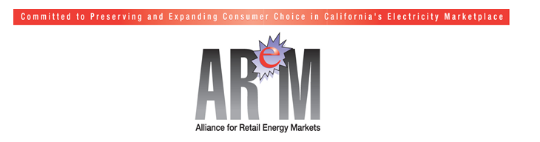

April 16, 2013

The Honorable Steven Bradford
Chair, Assembly Utilities and Commerce Committee
State Capitol, Room 5136
Sacramento, CA 95814

RE: Support Assembly Bill 1350: Expansion of Direct Access

Dear Chairman Bradford:

We thank the California legislature for the passage of Senate Bill 695 (Kehoe), enacted in 2009, allowing additional nonresidential customers to choose Direct Access service from competitive electric service providers (ESPs), subject to an overall cap. Because of the cap imposed by SB 695 on customer choice, however, there are many businesses, schools, hospitals, and other institutions in the state that are still unable to elect Direct Access for all or any portion of their electricity needs. Not only has each opportunity for customers to sign up for the limited space under the cap been vastly oversubscribed in a matter of seconds, each of the utilities indicate that the Direct Access cap in each utility service territory is fully subscribed.

SB 695 was a great start and customer response to date highlights the interest and desire of many California businesses and institutions desiring to choose Direct Access service as a way to take control of and manage their electricity costs. But the limitations imposed by the cap have proven to be too restrictive for the demand. To address this problem, we urge you to support new legislation, Assembly Bill 1350, introduced by Assembly Member Roger Hernandez. This bill provides for a modest expansion of the Direct Access cap using the same measured approach as adopted in SB 695, so that more California businesses, schools, hospitals and other institutions can participate in Direct Access.

It is important to note that ESPs who serve Direct Access customers must, under existing statutes, meet the same Renewable Portfolio Standard (RPS), Resource Adequacy (RA), and Greenhouse Gas (GHG) emissions reduction requirements imposed on the utilities. In fact, working one-on-one with their Direct Access customers, ESPs offer electricity and renewable energy products and services that are tailored to meet their customers’ electricity needs and their individual environmental and sustainability goals. So, not only are ESPs required to meet the same environmental goals as the utilities, they can also help their customers achieve better.

Moreover, Direct Access customers are required to pay the Power Charge Indifference Adjustment (PCIA, also known as the “exit fee”) when they switch from utility service to Direct Access. Payment of the exit fee ensures that there is no cost shifting to customers who remain on utility service because of another customer’s decision to go to Direct Access. Therefore, any assertion that customers who remain on utility service are economically harmed by Direct Access is simply misinformation.

Direct Access service is how many organizations such as universities, community colleges, K-12 schools, retail companies, government facilities, fast-foot chains, supermarkets, technology companies, food processors, and countless others have taken control of their electricity needs and costs. The ability to choose Direct Access should be made available to more of the businesses and institutions that are vital contributors to California’s economy.

AReM strongly urges your support of AB 1350 and the expansion of Direct Access that it provides.

Sincerely,

Andrea Morrison
President
Alliance for Retail Energy Markets

